**Source Code:**

**First, Sign up and Login to “https://openweathermap.org/api”**

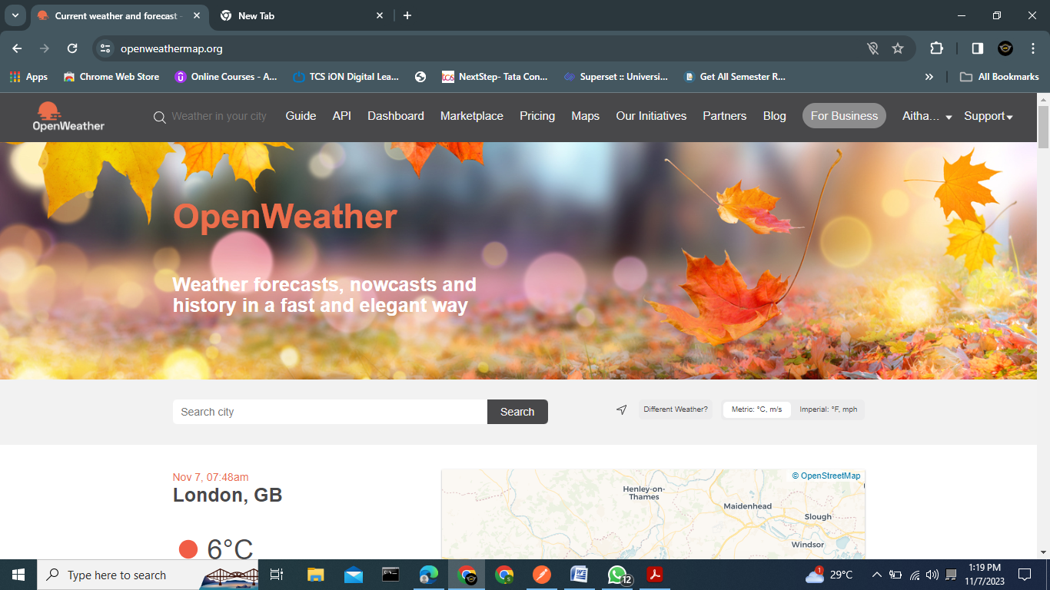

**Now create API keys -> click on My Account -> Click on My API keys as shown below:**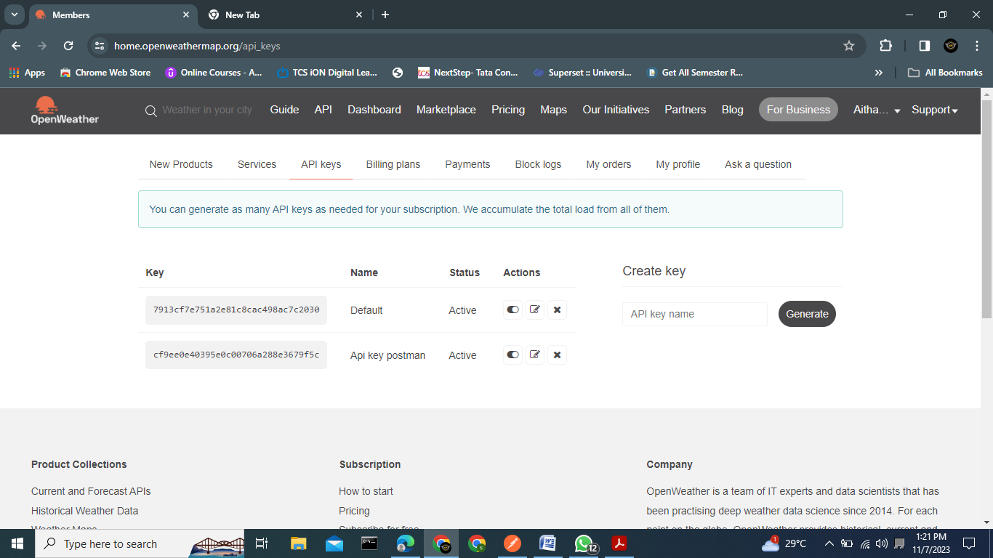

**After clicking on My API Keys -> There will be default key -> Or we can generate our own key.**

**(click on Generate ->New key will generate-> Give the name to key).**

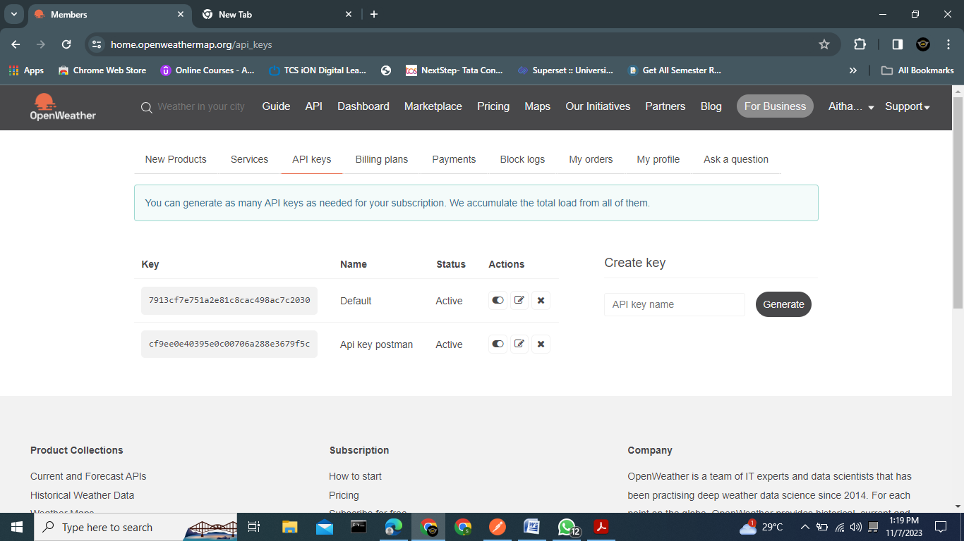

We use below API request in Postman tool:

**https://api.openweathermap.org/data/2.5/weather?q={city name}&appid={API key}**

**Open Postman** -> Give the details as shown below image

First create new collection named as Lesson2-End Project .

Than Add request named as openweatherreq.

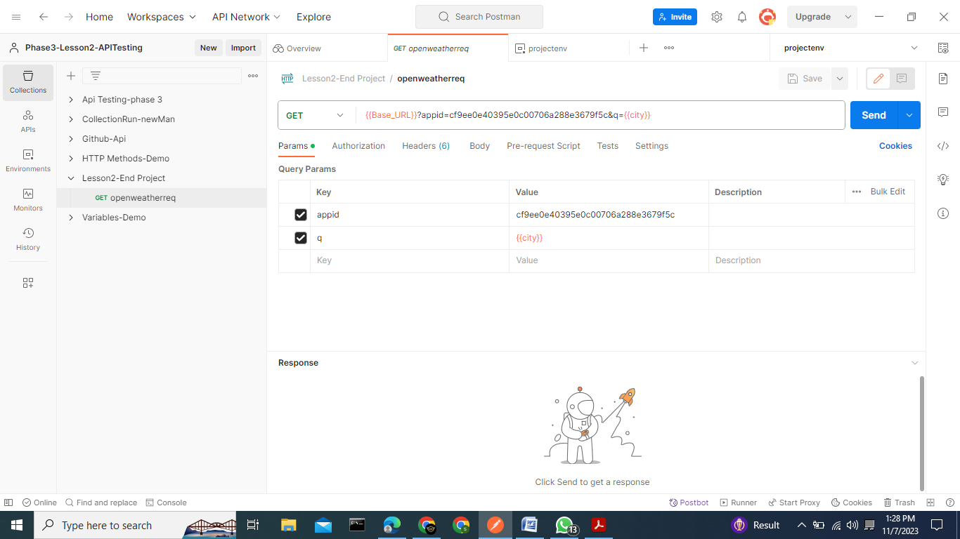

**Now create New Environment**

**Go to Environment Tab in postman**

**Create New environment named as projectenv.**

**And also create a variables which is given in collection as shown below**

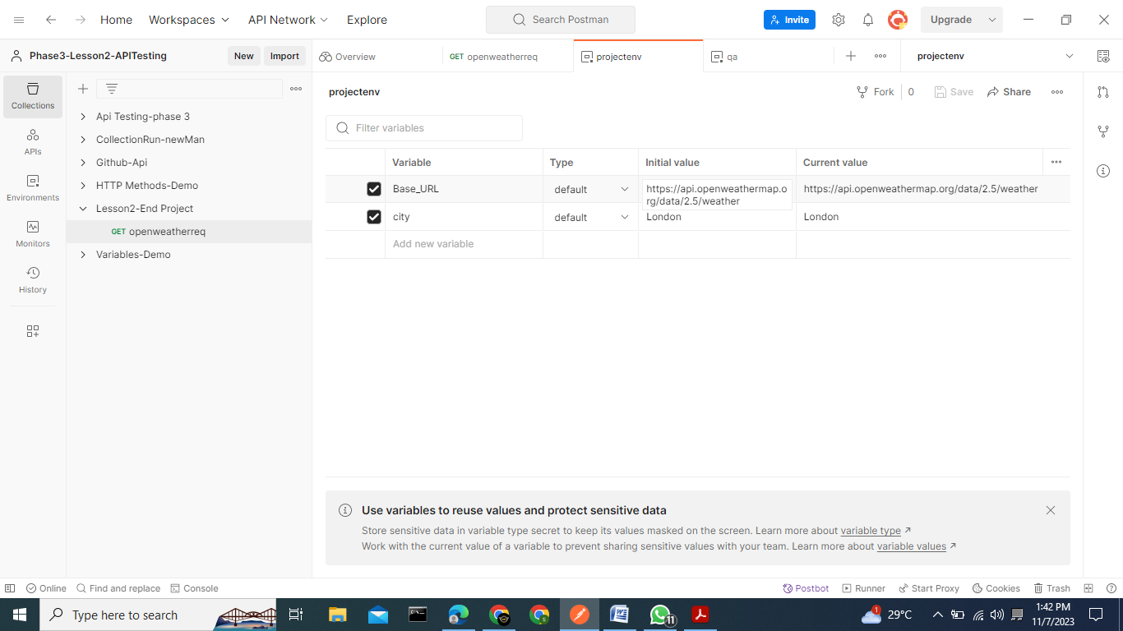

**Now goto collection tab select Lesson2_endproject ->than goto openweatherreq request**

**Now save the collection.**

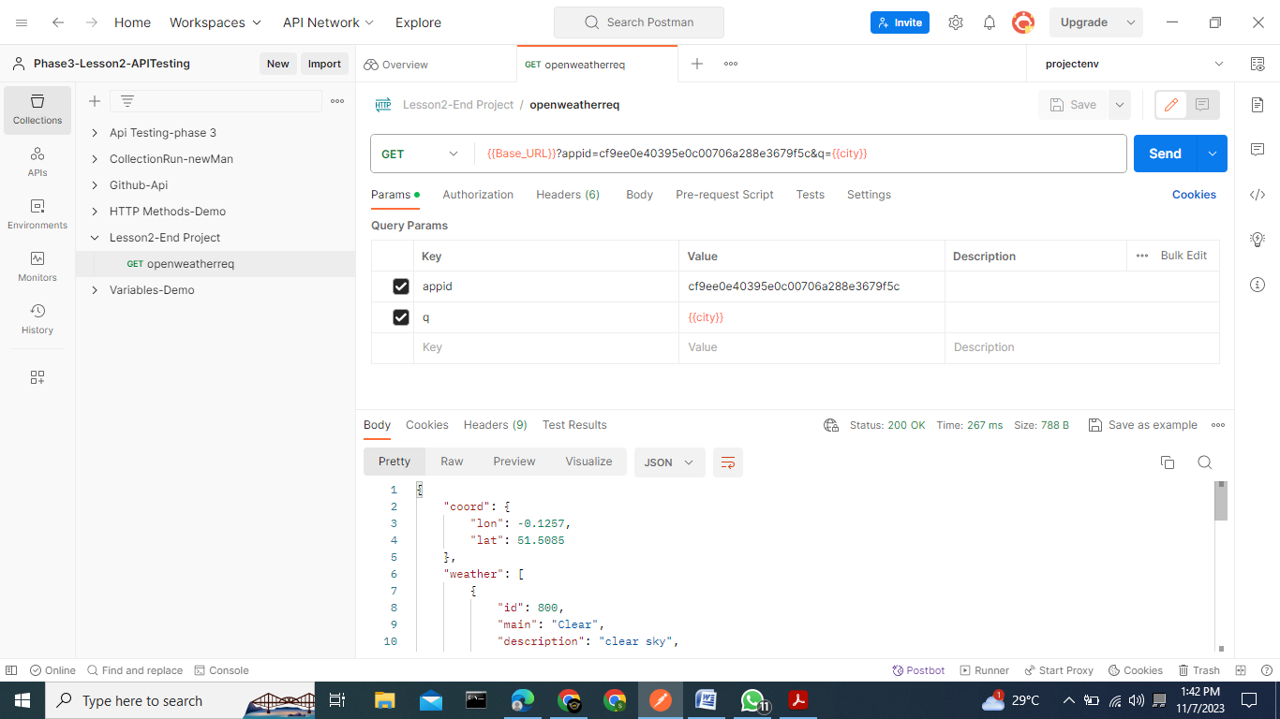

**Now** Save this request and click on Send to see output

